Full Stack Development
Summary

Inheritance
Advantages of Inheritance

Code Reusability
Avoid rewriting common logic.

Easy Maintenance
Updates in the superclass are reflected in subclasses.

Extensibility
Allows adding new features without changing old code.

Method Overriding
Enables polymorphism (same method, different behavior).

Organized Code
Promotes modular and structured programs.
Types of Inheritance in Java

- Single Inheritance.
- Multilevel Inheritance.
- Hierarchical Inheritance.
- Multiple Inheritance.
- Hybrid Inheritance.

Single Inheritance

A → B
One class inherits from another

Example Program
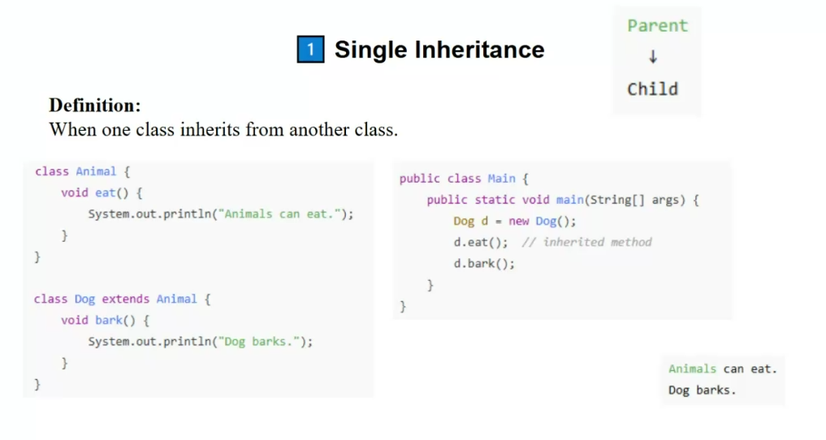

Multilevel Inheritance

A → B → C
Class inherits from a subclass

Example Program

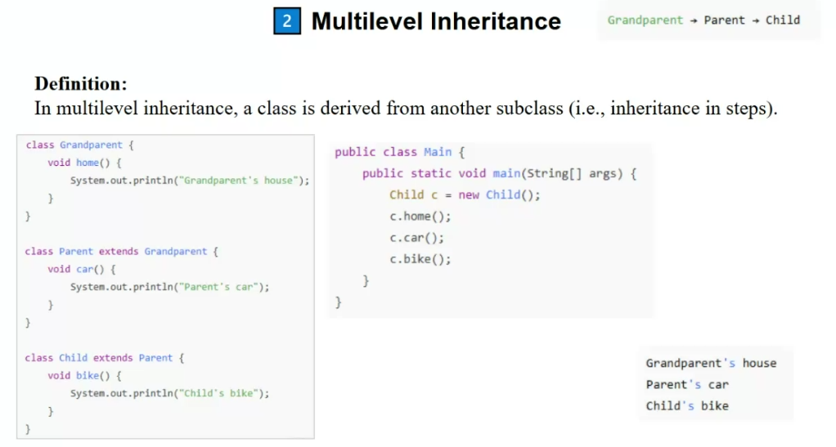

Hierarchical Inheritance

A → B, A → C
Multiple classes inherit from one superclass

Example Program

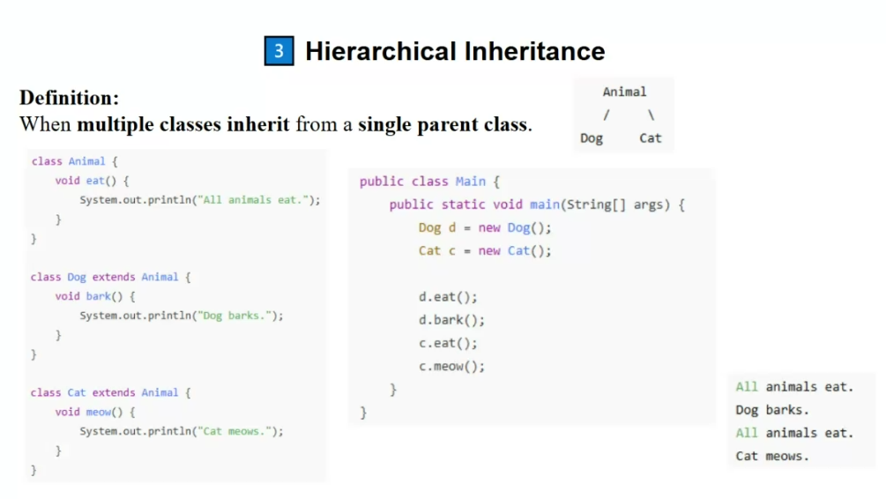
Multiple Inheritance
A, B → C
A class inherits from multiple classes (Not allowed with classes, allowed with interfaces)

Example Program
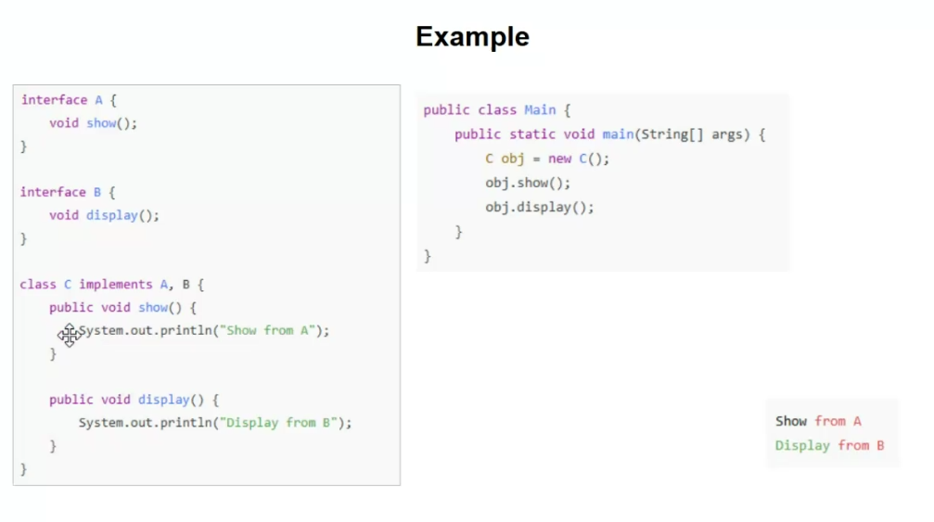
Hybrid Inheritance

Combination of above types.
Combination of above types (Not directly supported, achieved using interfaces)

Example Program
